Experiment 11 – Managing Input/ Output Files in Java Write a program to create a record by taking inputs using Scanner class as first name as string ,last name as string ,roll number as integer ,subject1 mark as float,subject2 mark as float. Perform the following tasks using file I/O: i. Write the said inputted records in the file “Student.dat” in the following format: name rollnumber avgmark". ii. Read and display the content of file “Student.dat” file and write it to another file “StudentBackup.dat”.

import java.io.BufferedReader;

import java.io.FileReader;

import java.io.FileWriter;

import java.io.IOException;

import java.io.PrintWriter;

import java.util.Scanner;

import java.util.StringTokenizer;

class std {

    String fname;

    String lname;

    int rno;

    float avg;

    std(String fn,String sn,int r,float s1){

        this.fname=fn;

        this.lname=sn;

        this.rno=r;

        this.avg=s1;

    }

    void display()

    {

        System.out.println(this.fname);

        System.out.println(this.lname);

        System.out.println(this.rno);

        System.out.println(this.avg);

    }

}

public class exp11 {

    public static void writefile(String file,std s)throws IOException

    {

        try{

            PrintWriter out=new PrintWriter(new FileWriter(file));

            out.println(s.fname+" "+s.lname+" "+s.rno+" "+s.avg);

            out.close();

        }

        catch(IOException e){

            System.out.println(e);

        }

    }

    public static void main(String[] args)throws IOException {

        Scanner sc=new Scanner(System.in);

        System.out.println("Enter the first name");

        String fn=sc.next();

        System.out.println("Enter the last name");

        String ln=sc.next();

        System.out.println("Enter the roll no");

        int rn=sc.nextInt();

        System.out.println("Enter the marks of subject 1");

        float s1=sc.nextFloat();

        System.out.println("Enter the marks of subject 2");

        float s2=sc.nextFloat();

        std s=new std(fn,ln,rn,(s1+s2)/2);

        writefile("Students.dat",s);

        try{

            BufferedReader in=new BufferedReader(new FileReader

("Students.dat"));

            String str=in.readLine();

            StringTokenizer t=new StringTokenizer(str," ");

            String fnn=t.nextToken();

            String snn=t.nextToken();

            int rnn=Integer.parseInt(t.nextToken());

            float sb=Float.parseFloat(t.nextToken());

            std std1=new std(fnn,snn,rnn,sb);

            std1.display();

            writefile("StudentBackup.dat", std1);

            in.close();

        }

        catch(IOException e)

        {

            System.out.println(e);

        }

    }

}

OUTPUT:-

\ 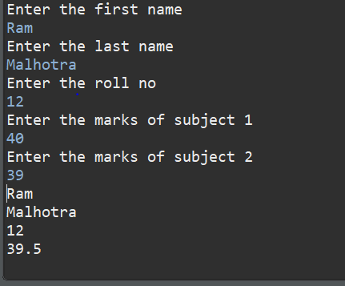

File Screenshots:-

